**Case study 2**

**Aim -** To learn case study for Software Development Life Cycle (SDLC).

**Theory -**

**1. What is a secure SDLC and why is it important?**

A Secure Software Development Life Cycle (SDLC) is a systematic and structured approach to building and delivering software applications with a primary focus on security. It involves integrating security practices and measures throughout the entire software development process, from the initial planning and design stages to coding, testing, deployment, and maintenance. The goal of a Secure SDLC is to identify and address security vulnerabilities early in the development process, reducing the risk of security breaches and data leaks in the final product.

Here are the key steps in a typical Secure SDLC:

1. Requirements Gathering and Analysis: Identifying security requirements and understanding potential risks and threats the software might face.

2. Design: Creating a secure architecture and design, considering security principles and best practices.

3. Implementation: Writing secure code and following coding guidelines to prevent common vulnerabilities like SQL injection, cross-site scripting (XSS), etc.

4. Testing: Conducting various security testing activities, such as vulnerability scanning, penetration testing, and code reviews, to identify and fix security flaws.

5. Deployment: Ensuring secure installation and configuration of the software in the production environment.

6. Maintenance and Updates: Regularly monitoring and updating the software to address new security threats and vulnerabilities.

**Importance of Secure SDLC:**

**1. Risk Mitigation:** A Secure SDLC helps identify and address security vulnerabilities early in the development process, reducing the risk of security breaches and their associated consequences.

**2. Cost-Efficiency:** Fixing security issues at later stages of development or in the production environment can be significantly more expensive and time-consuming than addressing them during the development process.

**3. Compliance and Regulations:** Many industries and jurisdictions have specific security and privacy regulations. Following a Secure SDLC can help organizations comply with these requirements.

**4. Reputation and Trust:** Building secure software enhances the reputation of the organization and fosters trust among customers and users.

**5. Customer Confidence:** Users are more likely to use and recommend software that they believe is secure and protects their sensitive data.

**6. Long-term Sustainability:** Secure software is less likely to be affected by security incidents, leading to a more sustainable product life cycle.

Overall, a Secure SDLC is essential for organizations to build robust, resilient, and secure software that can withstand the evolving threat landscape and protect sensitive data and critical systems effectively.

**2. What are the steps/phases of SDLC?**

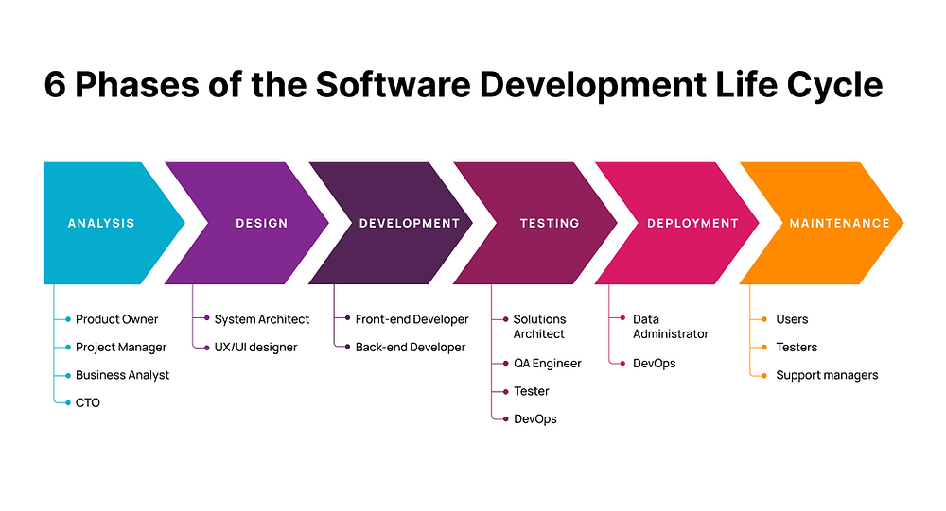

The Software Development Life Cycle (SDLC) is a structured approach that guides the development of software applications from initial planning to deployment and maintenance. The SDLC consists of several phases, each with specific activities and deliverables. While different methodologies may have variations in the names or the number of phases, the core steps are typically as follows:

**1. Requirements Gathering:**

* Identify and gather detailed requirements from stakeholders, users, and customers.
* Define the functionality, features, and constraints of the software.

**2. Analysis:**

* Analyze the gathered requirements to ensure they are clear, complete, and feasible.
* Create detailed documentation outlining the functional and non-functional requirements.

**3. Design:**

* Create a comprehensive design that translates the requirements into a technical solution.
* Define the software architecture, data structures, algorithms, and user interface.

**4. Implementation (Coding):**

* Write the code based on the design specifications.
* Developers follow coding standards and best practices to ensure the code is maintainable and secure.

**5. Testing:**

* Conduct various testing activities to validate the software's functionality and quality.
* This phase includes unit testing, integration testing, system testing, and user acceptance testing.

**6. Deployment:**

* Deploy the software in the production environment or make it available to end-users.
* This phase involves installation, configuration, and data migration (if necessary).

**7. Maintenance:**

* Provide ongoing support, bug fixes, and updates to the software to address issues discovered in the production environment.
* Enhance the software to meet changing user needs or add new features.

These are the fundamental phases of the SDLC. It's important to note that many organizations and development teams also integrate security measures throughout the SDLC, which leads to the concept of the Secure SDLC, as mentioned in the previous question. Additionally, modern software development methodologies like Agile and DevOps may combine or streamline some of these phases to achieve faster and more iterative development cycles.

**Conclusion -**

In conclusion, both the Secure Software Development Life Cycle (SDLC) and the standard SDLC are essential for building secure, high-quality software applications. The Secure SDLC ensures that security is integrated throughout the development process, reducing the risk of breaches and vulnerabilities. On the other hand, the standard SDLC provides a structured framework for the entire development process, leading to efficient and well-organized software development. By combining these approaches, organizations can create trustworthy and resilient software while meeting user needs and industry standards.